Final Project in Approximation Theory

1. Theory

**Definition 1.1** A set of distinct points $a≤x_{0}<x_{1}<…<x_{n}≤b$ is called **alternating set** for $f\left(x\right)$ if

$\left|f\left(x_{i}\right)\right|={\left\|f\right\|}_{∞} and f\left(x_{i}\right)=-f\left(x_{i-1}\right) for all i=1,…,n$.

**Lemma 1.2** If $\left|a\right|>\left|b\right|$ then $a$ and $a-b$ has the same sign.

**Proof:**

If $a>0$, then $a-b>0$ because

$$\left|a\right|>\left|b\right|⇒\left|a\right|-\left|b\right|>0⇒a-\left|b\right|>0⇒a-b≥a-\left|b\right|>0$$

If $a<0$ then $a-b<0$ because

$$\left|a\right|-\left|b\right|>0⇒\left|b\right|-\left|a\right|<0⇒\left|b\right|+a<0⇒a-b≤a+\left|b\right|<0$$

$$∎$$

**Theorem 1.3(The question)** Show that for $f∈C\left[a,b\right]$, and $p∈P_{n}\left[x\right]$; If $f-p$ has an alternating set containing $n+2$ (Or more) points, then $p$ is the best approximation to $f$ out of $P_{n}\left[x\right]$.

**Proof:**

I will prove by contradiction:

We know that $f∈C\left[a,b\right]$, and $p∈P_{n}\left[x\right]$ and $f-p$ has an alternating set containing $n+2$ (Or more) points.

By contradiction p is not the best approximation to $f$ out of $P_{n}\left[x\right]$. Therefore, exist another function $q∈P_{n}[x]$ such that:

$${\left\|f-p\right\|}_{∞}>{\left\|f-q\right\|}_{∞}$$

And we will look on alternating set of $f-p$ of n+2 points

$a≤x_{0},…x_{n+1}≤b$:

$$\left|f\left(x_{i}\right)-p\left(x_{i}\right)\right|={\left\|f-p\right\|}_{∞}>{\left\|f-q\right\|}_{∞}≥\left|f\left(x_{i}\right)-q\left(x_{i}\right)\right|$$

$$for each i=0,…,n+1$$

Therefore:

$$\left|f\left(x_{i}\right)-p\left(x_{i}\right)\right|>\left|f\left(x_{i}\right)-q\left(x_{i}\right)\right| for each i=0,…,n+1$$

Then $f\left(x_{i}\right)-p\left(x_{i}\right) and f\left(x_{i}\right)-p\left(x_{i}\right)-\left(f\left(x_{i}\right)-q\left(x_{i}\right)\right)$ has the same sign (From lemma 1.2). Therefore $f\left(x_{i}\right)-p\left(x_{i}\right) and q\left(x_{i}\right)-p\left(x_{i}\right)$ has the same sign for each $i=0,…,n+1$.

And we know that $q\left(x_{i}\right)-p\left(x_{i}\right)∈P_{n}\left[x\right]⊆C\left[a,b\right]$ (From closeness of set $P_{n}\left[x\right]$). So, we got that $q\left(x_{i}\right)-p\left(x_{i}\right)$ alternate sign in

$\left[x_{0},x_{1}\right],\left[x_{1},x_{2}\right],…,\left[x_{n},x_{n+1}\right]$ sections, and from **Intermediate value theorem** we got n+1 zero (In each section there is zero).

$q\left(x_{i}\right)-p\left(x_{i}\right)∈P_{n}\left[x\right]$ and has n+1 zero therefore $q\left(x_{i}\right)-p\left(x_{i}\right)≡0$ therefore $q\left(x_{i}\right)≡p\left(x_{i}\right)$ **Contradiction! $∎$**

1. Practice

I used two algorithms in MATLAB (I did 3 but the first one is just a line; you can see in the links and pictures) to find best approximation plot of continuous function the corona's data.

Algorithm 1 according to [2]:

1. Choose the order **k** of polynomial function.
2. Build matrix according to points $\left(x_{i},y_{i}\right)$:
$$X=\left(\begin{matrix}{x_{1}^{k}…x}_{1}^{2} & x_{1} & 1 \\ x_{2}^{k}…x_{2}^{2} & x_{2} & 1 \\ … & … & …\end{matrix}\right)$$

3. Solve equation:

$$\hat{β}={\left(X^{T}X\right)}^{-1}X^{T}y$$

Algorithm 2(my algorithm):

1. Do algorithm 1 to get Maclaurin series
2. Build matrix of equations:

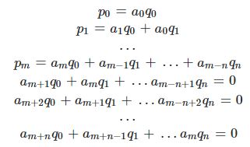

1. Solve Matrix equation from step 2

* There is a huge downside of algorithm 2 that he is **local approximation** which means that in x big enough the function will explode.

Results (From data in link [4] and looking on Israel corona cases):

Algorithm 3:

K=3

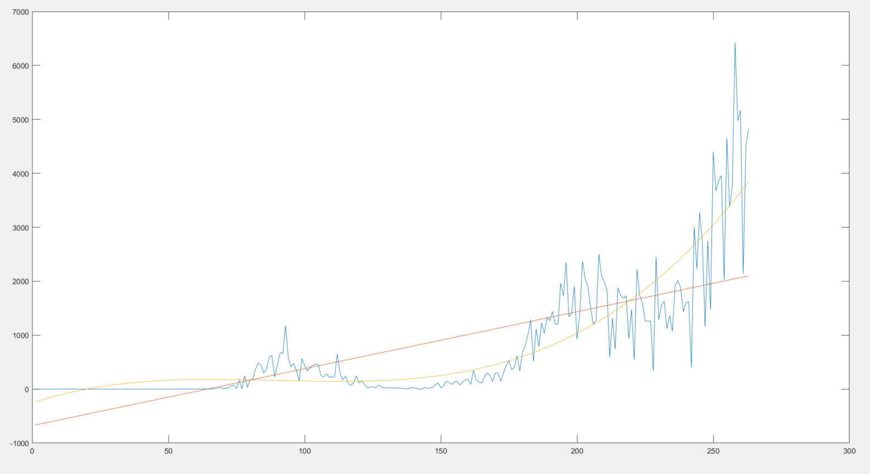

K=63

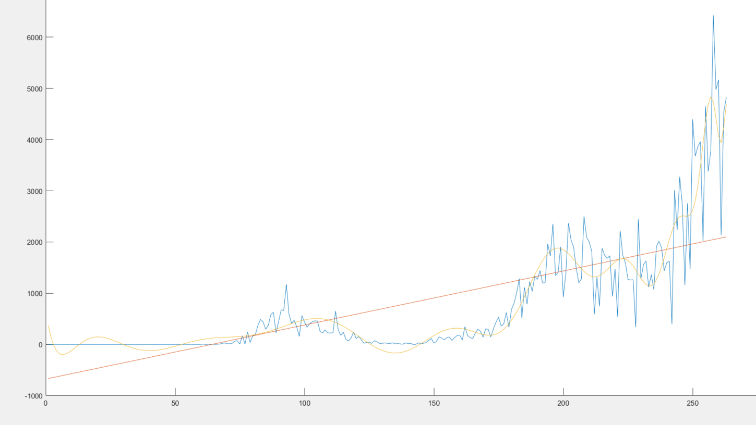

Blue - Real function.

Yellow – Best linear least squares according algorithm 1.

Red – Line linear least squares (according to [1]).

Algorithm 2:

When k=63

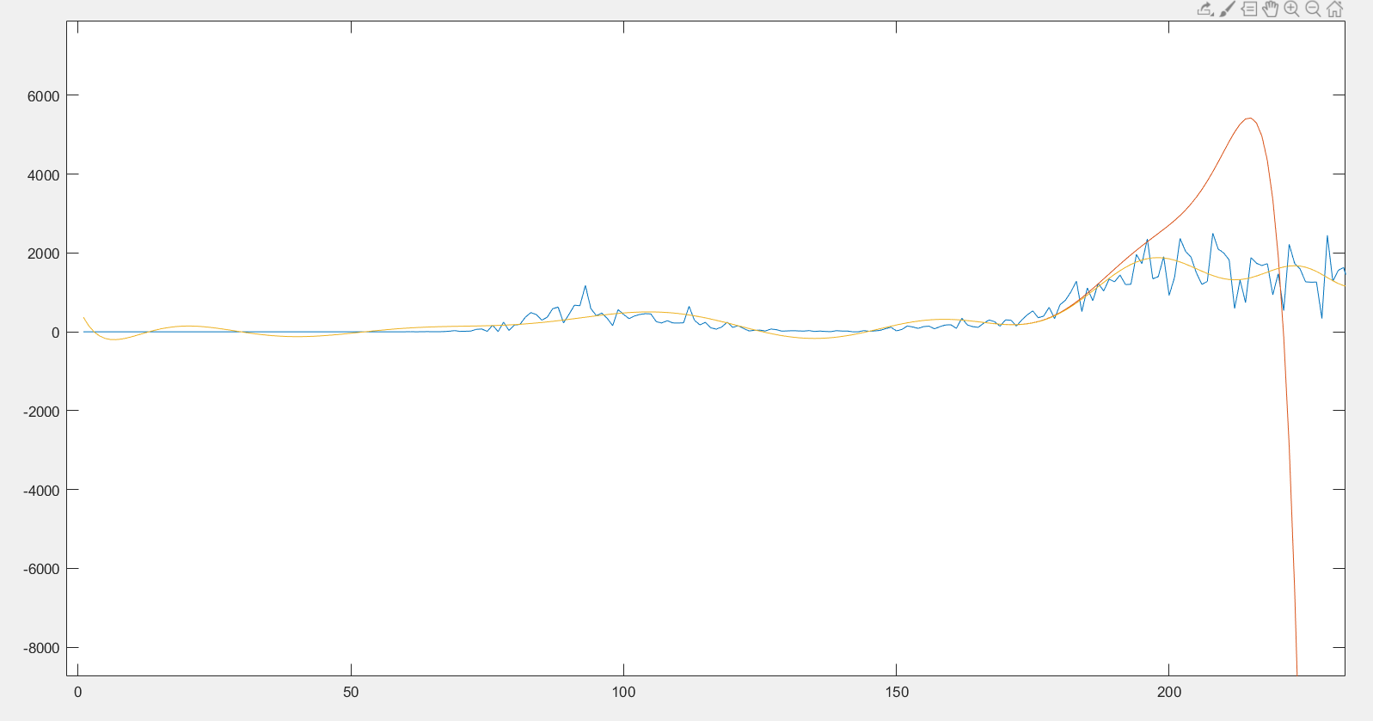Blue - Real function.

Yellow – Best linear least squares according algorithm 1.

Red – Pade's approximation according algorithm 2.

We can see that in roughly around 170 red starts to explode.

Notes:

1. Although k=63 gives better results than k=3 in algorithm 1 it will fail to predict future results because of **overfitting**.
2. Red line in the first two graphs is good example of **underfitting**.
3. Algorithm 2 failed horribly because its local approximation (In my opinion it was good to see example of bad algorithm).
4. There exist some good algorithms for pade's approximation (SVD, Wynn identity etc.).

[1] <https://en.wikipedia.org/wiki/Linear_least_squares#Example> (Private case of linear least squares of order 2)

[2] <https://en.wikipedia.org/wiki/Linear_least_squares#Main_formulations>

[3] <https://math.stackexchange.com/questions/860293/how-to-compute-the-pade-approximation>

[4] <https://data.europa.eu/euodp/en/data/dataset/covid-19-coronavirus-data/resource/55e8f966-d5c8-438e-85bc-c7a5a26f4863>

Code in github:

<https://github.com/niroosh1997/Approximation-Final-Project>